# Conda Installation

Official installation and usage documentation can be found at <https://conda.io/projects/conda/en/latest/user-guide/install/index.html>.

## Miniconda

Miniconda is a free minimal installer for conda. It is a small, bootstrap version of Anaconda that includes only conda, Python, the packages they depend on, and a small number of other useful packages, including pip, zlib and a few others. Use the conda install command to install 720+ additional conda packages from the Anaconda repository.

Linux

Linux package managers are usually updated less often so grabbing the latest installer from the anaconda website is preferable. While logged in to a Linux system download the miniconda installer by running the following command:

| wget https://repo.anaconda.com/miniconda/Miniconda3-latest-Linux-x86_64.sh |
| --- |

You can then run the installer by running:

| bash Miniconda3-latest-Linux-x86_64.sh |
| --- |

Press **ENTER** to proceed with the installation and type in ‘yes’ to accept the license terms.

When you get a prompt about the installation location, the default should be under your home directory. Press **ENTER** again to accept or type in a preferred location if applicable.

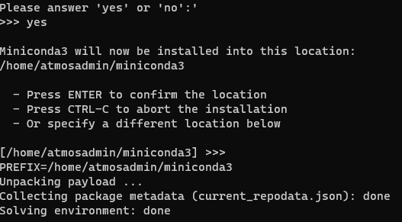

The installation script will now proceed and the next prompt will appear:

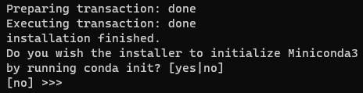

Typing yes will modify your **.bashrc** file so that conda will be activated every time you log in.

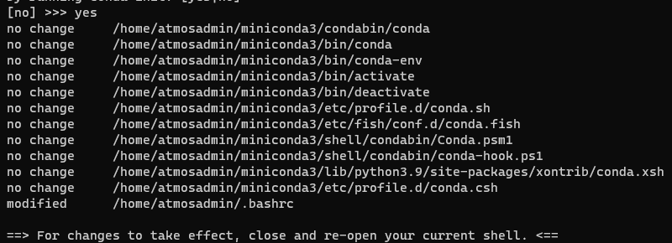

Instead of closing and opening your terminal, you can instead run the following command to activate conda: source .bashrc

## Python Environments

Official usage documentation can be found at <https://docs.conda.io/projects/conda/en/latest/user-guide/tasks/manage-environments.html>

Once conda is installed you are now ready to create and activate your conda environments.

Create an environment and specify a python version. Note, without specifying the python version, the default will be Python 2.7.18

| conda create -n myenv python=3.9 |
| --- |

Where ‘myenv’ can be any name you want to call your environment.

To use the environment you just created, type in:

| conda activate myenv |
| --- |

This changes the shell configuration by making your primary python the customized version of python installed in the myenv (or whatever name is used) directory.

If you need to exit the environment:

| conda deactivate |
| --- |

## Conda Packages

Official documentation can be found at <https://docs.anaconda.com/anaconda/user-guide/tasks/install-packages/>

Conda packages can be installed to the current environment with the **conda install** command, the **-n myenv** is optional and is used to specify the environment to install a package to.

| conda install package-name -n myenv |
| --- |

It is advisable to try to install packages with conda first before using pip in a conda environment. If pip is necessary it can be set up by

| conda install -n myenv pip conda activate myenv pip <pip_subcommand> |
| --- |